**CORSICA USER MANUAL**

Old Dominion University

CS 411 Red Team

Fall 2014

**Authors:**

Anthony Baron

Patrick DeBerry

Latimer Gerle

Nicholas LoGioco

Bitaseme Mboe

Lookmai Rattana

**Table of Contents**

1. Introduction (Patrick)……….……………………………………………………………. 3
2. Getting Started (Latimer) ………………………………………………………………... 4

2.1 Group Website ……………………………………………………………………. 4

2.2 Signup …………………………………………………………………………….. 5

2.3 Login ……………………………………………………………………………… 8

1. Search (Bitaseme) ……………………………………………………………………….. 9
2. Waitlist (Nicholas) ……………..………………………………………………………. 14
3. User Accounts (Anthony)………………………………………………………………. 20

5.1 Administrator User……………………………………………………………….. 20

Administrator Dashboard……………………………………………………….. 21

Administrator Search …………………………………………………………... 22

Administrator Wait-list detail ………………………………………………….. 23

5.2 Advisor User……………………………………………………………………… 24

Advisor Dashboard …………………………………………………………….. 24

Advisor Search …………………………………………………………………. 25

Advisor Student Detail …………………………………………………………. 25

Advisor Wait-list detail ………………………………………………………… 25

5.3 Scheduler User …………………………………………………………………... 25

Scheduler Dashboard …………………………………………………………... 25

Scheduler Search ……………………………………………………………….. 25

Scheduler Wait-list detail ………………………………………………………. 25

5.4 Student User ……………………………………………………………………... 25

Student Dashboard ……………………………………………………………... 26

Student Search …………………………………………………………………. 26

Student Wait-list Sign Up ……………………………………………………… 27

5.5 Visitor User ……………………………………………………………………… 28

1. Troubleshooting (Lookmai) ……………………………………………………………. 29
2. **Introduction (Patrick)**

CORSICA is a wait-list management system developed by Old Dominion University's CS411 Red Team during the Fall 2014 semester. CORSICA is an improvement for the current CS department's wait-list. CORSICA will provide students and faculty with a friendly web interface which will communicate with the school's central scheduling database. In place of a manual list being keep by advisors, CORSICA will add student to the course's wait-list in a fair and efficient manner. The following sections will provide detailed directions for using the CORSICA webpage and some basic troubleshooting for issues that may occur.

(This space intentionally left blank)

1. **Getting Started (Latimer)**

To begin using CORSICA, you must first open an Internet browser and navigate to the website, located at http://red411.herokuapp.com/client. Upon doing so, you will be greeted by the CORSICA login page, shown below.

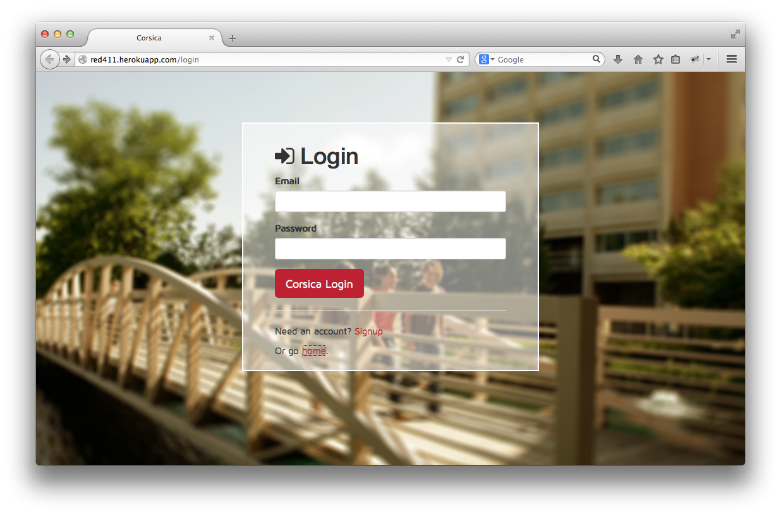

*Figure 1. CORSICA Login Page*

**2.1 Group Website**

By clicking on the ‘home’ link, you will be taken to the CORSICA team website (as opposed to CORSICA itself), as shown in Figure 2.

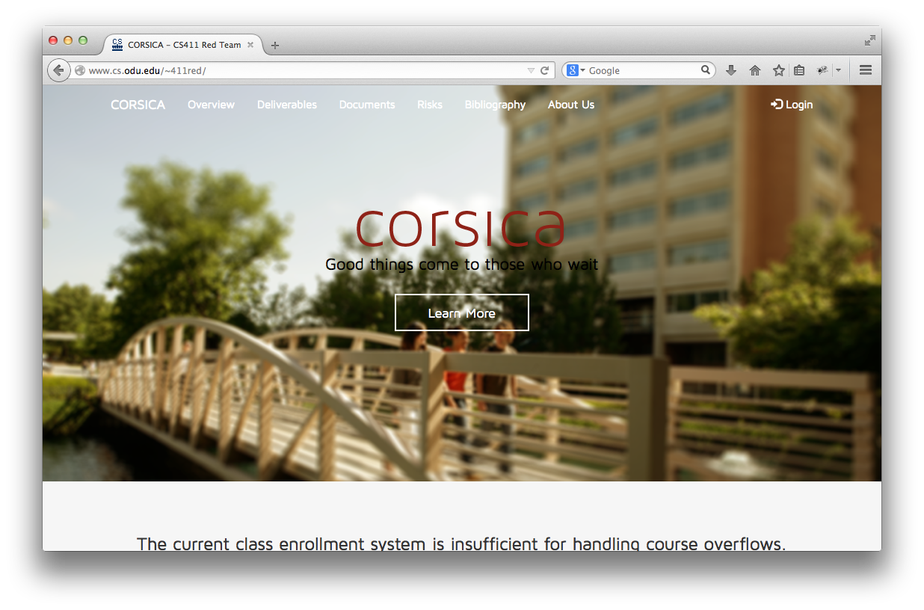

*Figure 2. CORSICA Team Website*

Here, you will find information about the project, as well as viewable labs and presentations.

**2.2 Signup**

If a user has never logged on to CORSICA before, he or she must first sign up. To do this, you would click on the ‘Signup’ link on the login page (see Figure 1). After doing so, you will be taken to the Signup page, as shown in Figure 3.

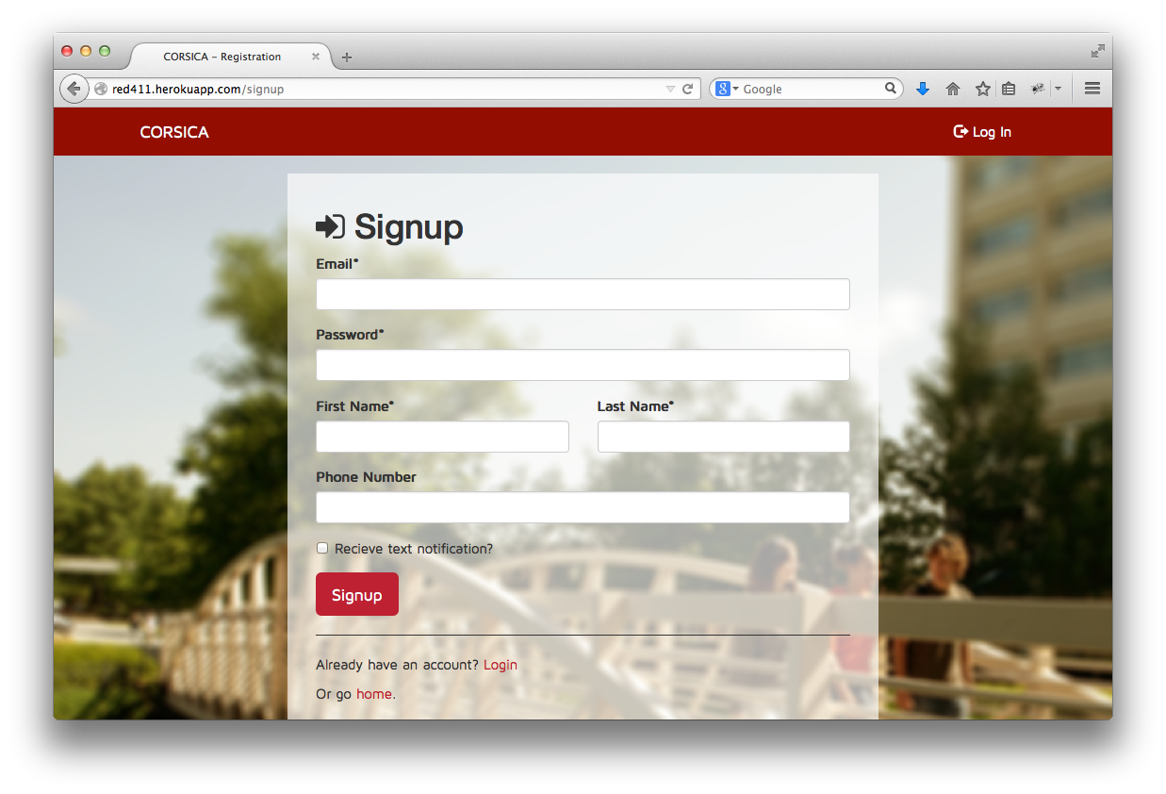

*Figure 3. Initial Signup Page*

Once on the Signup page, you can now enter in all of your pertinent information. Fields that are starred are required; however, if you are a student and would like to receive text notifications if a registration spot opens up in a closed class, you must enter your phone number and check the ‘Receive Text Notification’ checkbox. Once you’ve typed valid information into all of the required fields, your CORSICA page should resemble that of Figure 4.

(This space intentionally left blank.)

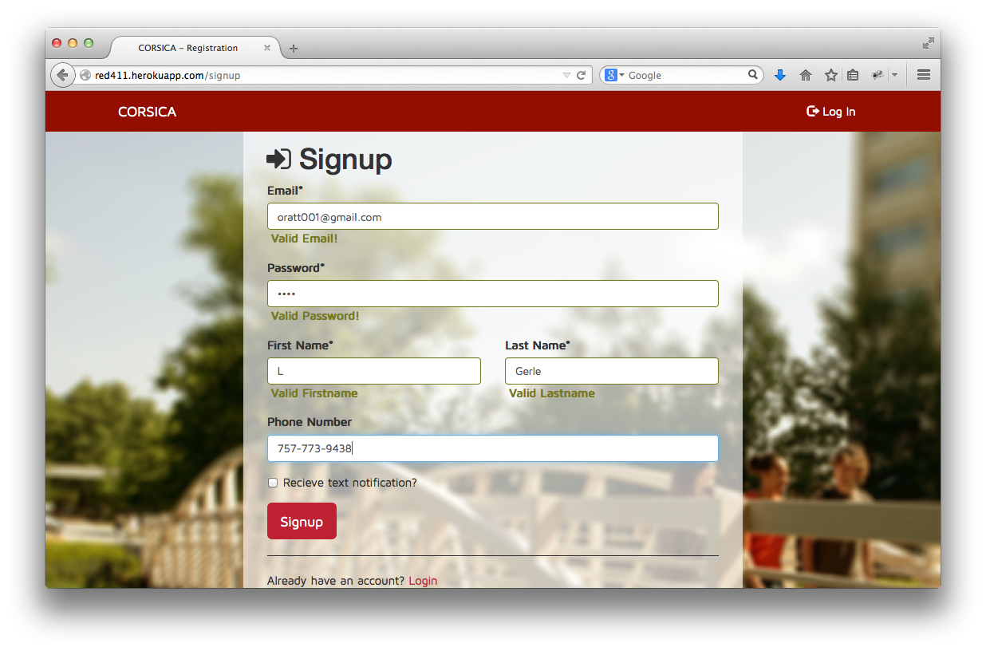

*Figure 4. Initial Signup Page with Information*

Then you will click the ‘Signup’ button at the bottom of the page; doing so will register you with CORSICA and take you to the home page, which is shown in Figure 5.

(This space intentionally left blank.)

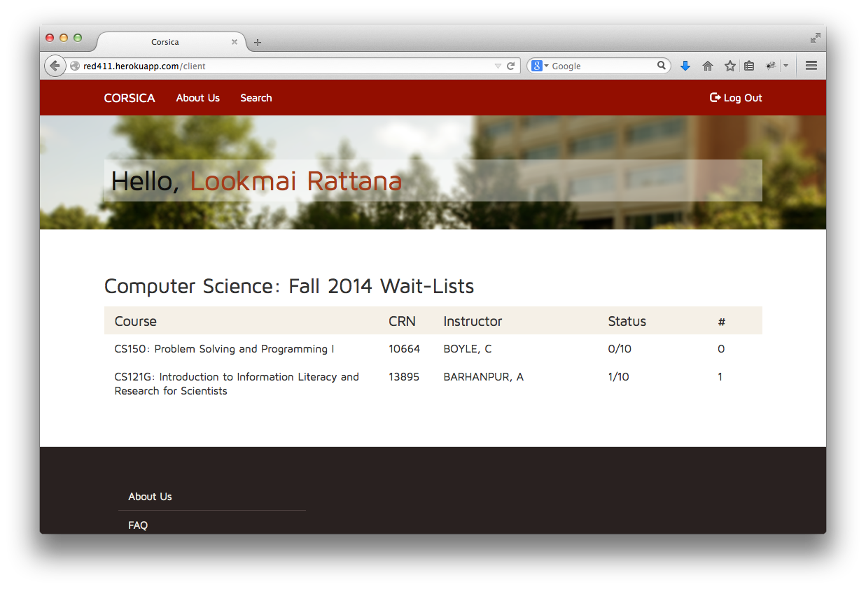

*Figure 5. CORSICA Home Page*

**2.3 Login**

If you have already registered with CORSICA, you can simply type in your email address and password at the Login page (see Figure 1); you will then be taken to your CORSICA home page (see Figure 5).

(This space intentionally left blank)

1. **Search (Bitaseme)**

CORSICA makes it easy to search for a particular course’s wait-list. You can search by:

* Course Name
* CRN
* Instructor’s Last Name
* Keyword

*\*\*Note: Search works for only Administrators, Schedulers, Advisors, and Students. Consequently, a user must sign in to CORSICA to use Search.\*\**

To use Search (Administrator):

1. Click on the word “Search” at the top of the page. You will then see the following screen:

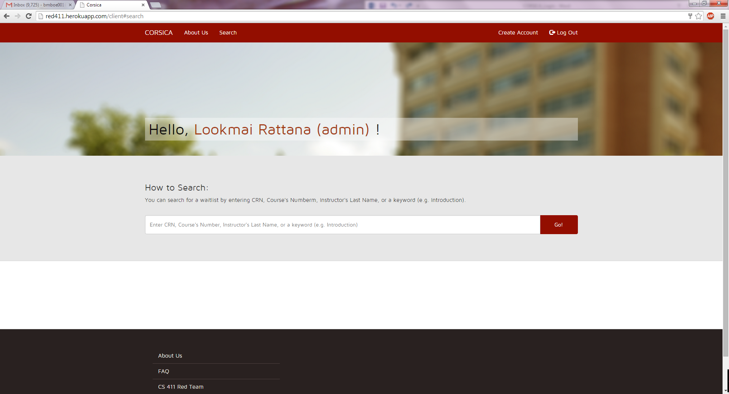

1. From here it’s pretty easy. Just type in the CRN, course number, Instructor’s Last Name, or keyword.

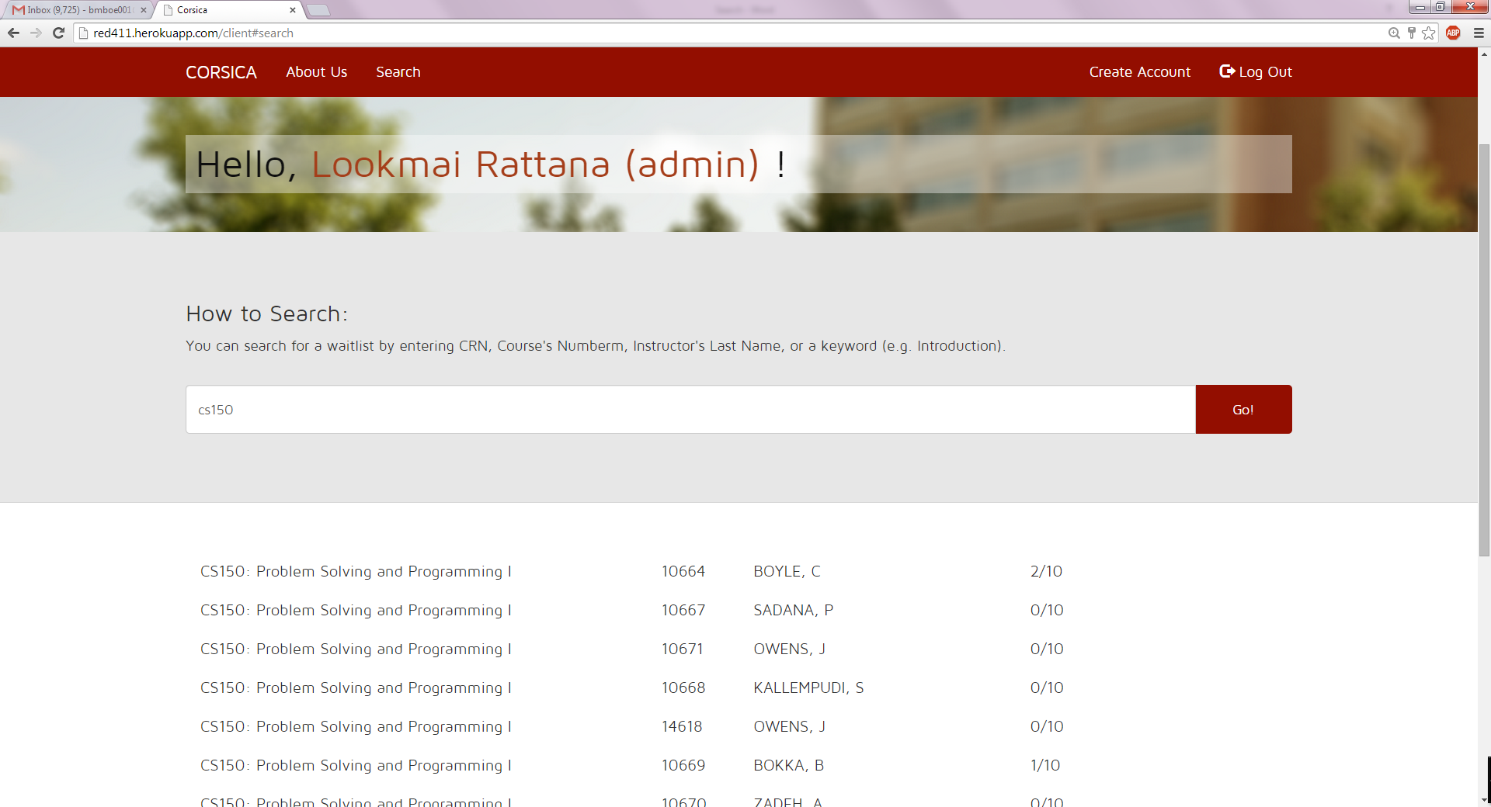

To use Search (Schedulers):

1. Click on the word “Search” at the top of the page. You will then see the following screen:

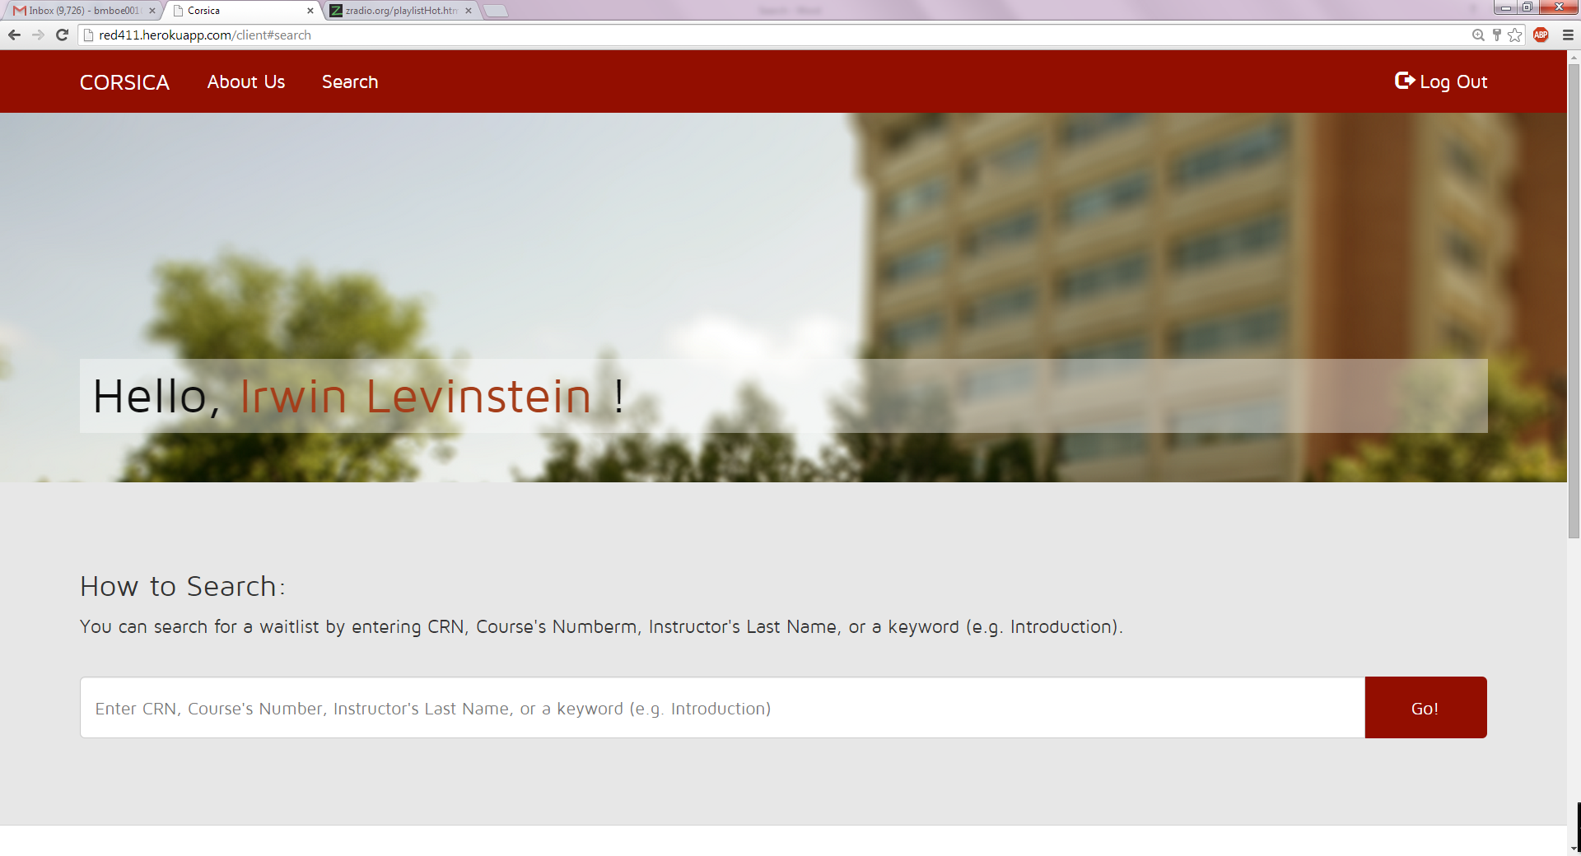

1. From here it’s pretty easy. Just type in the CRN, course number, Instructor’s Last Name, or keyword.

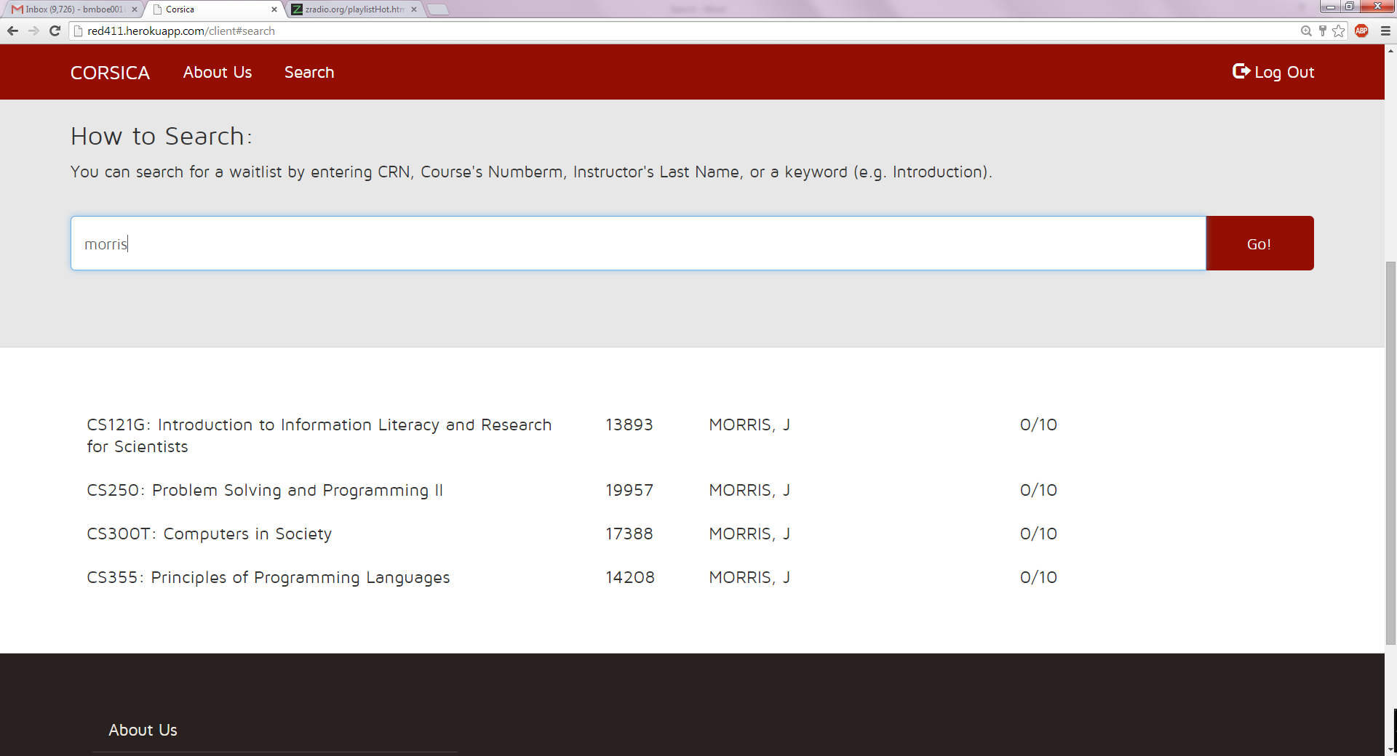

To use Search (Advisors):

1. Click on the word “Search” at the top of the page. You will then see the following screen:

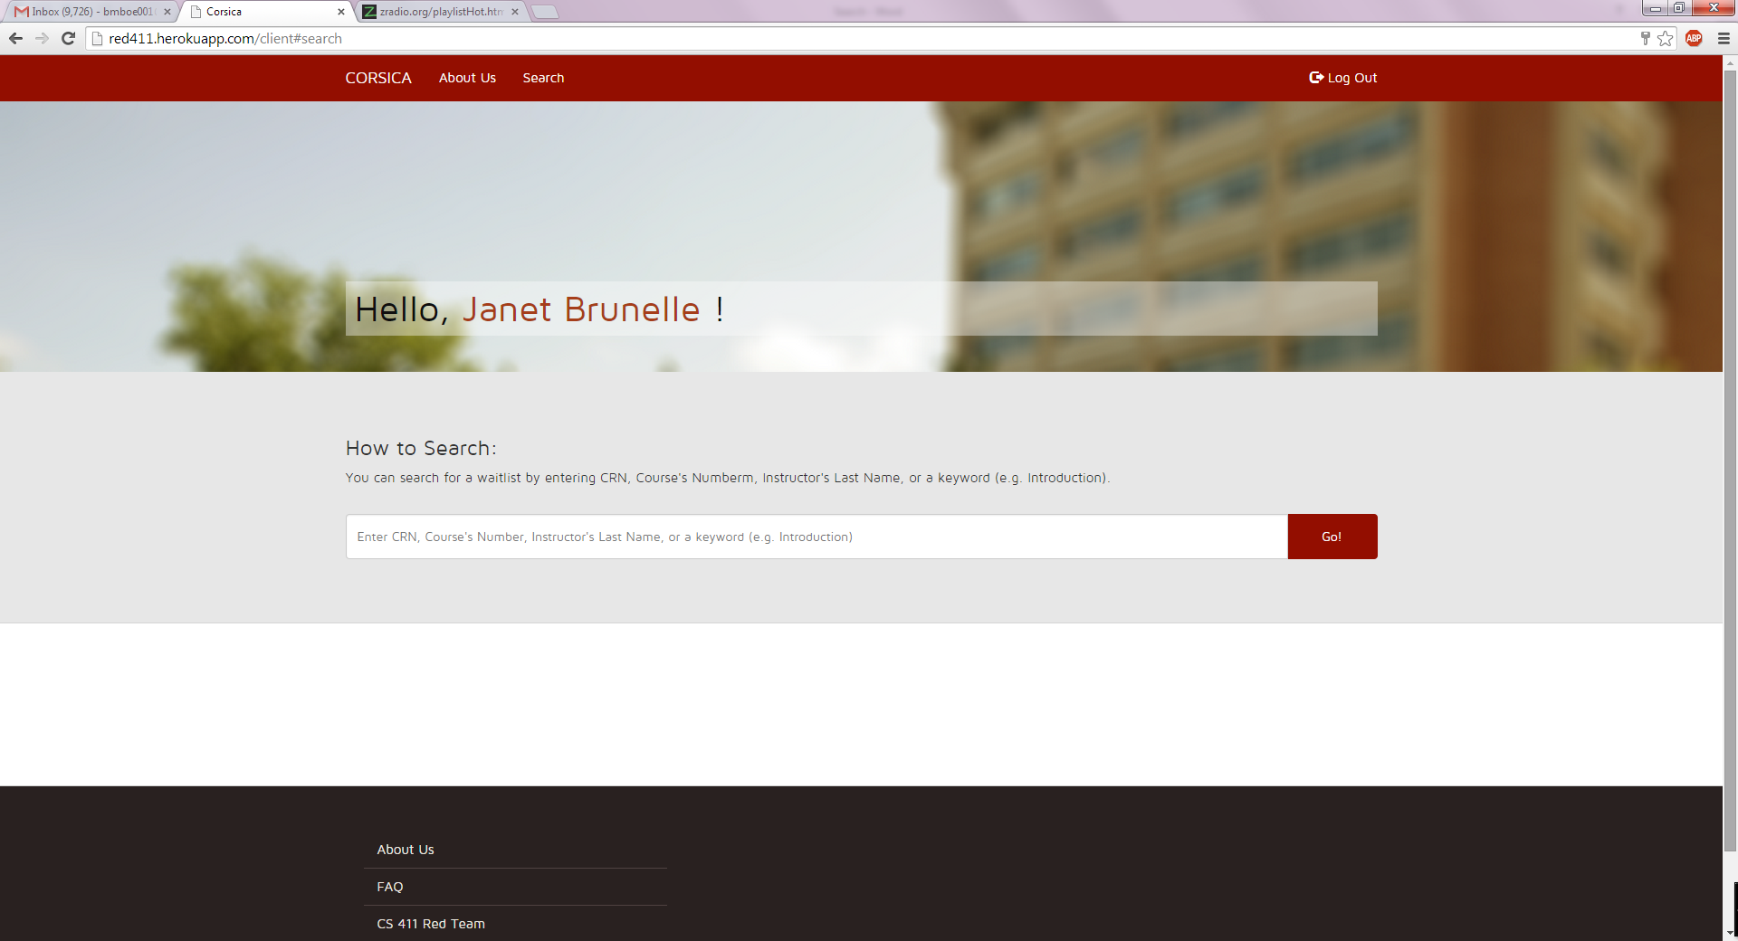

1. From here it’s pretty easy. Just type in the CRN, course number, Instructor’s Last Name, or keyword.

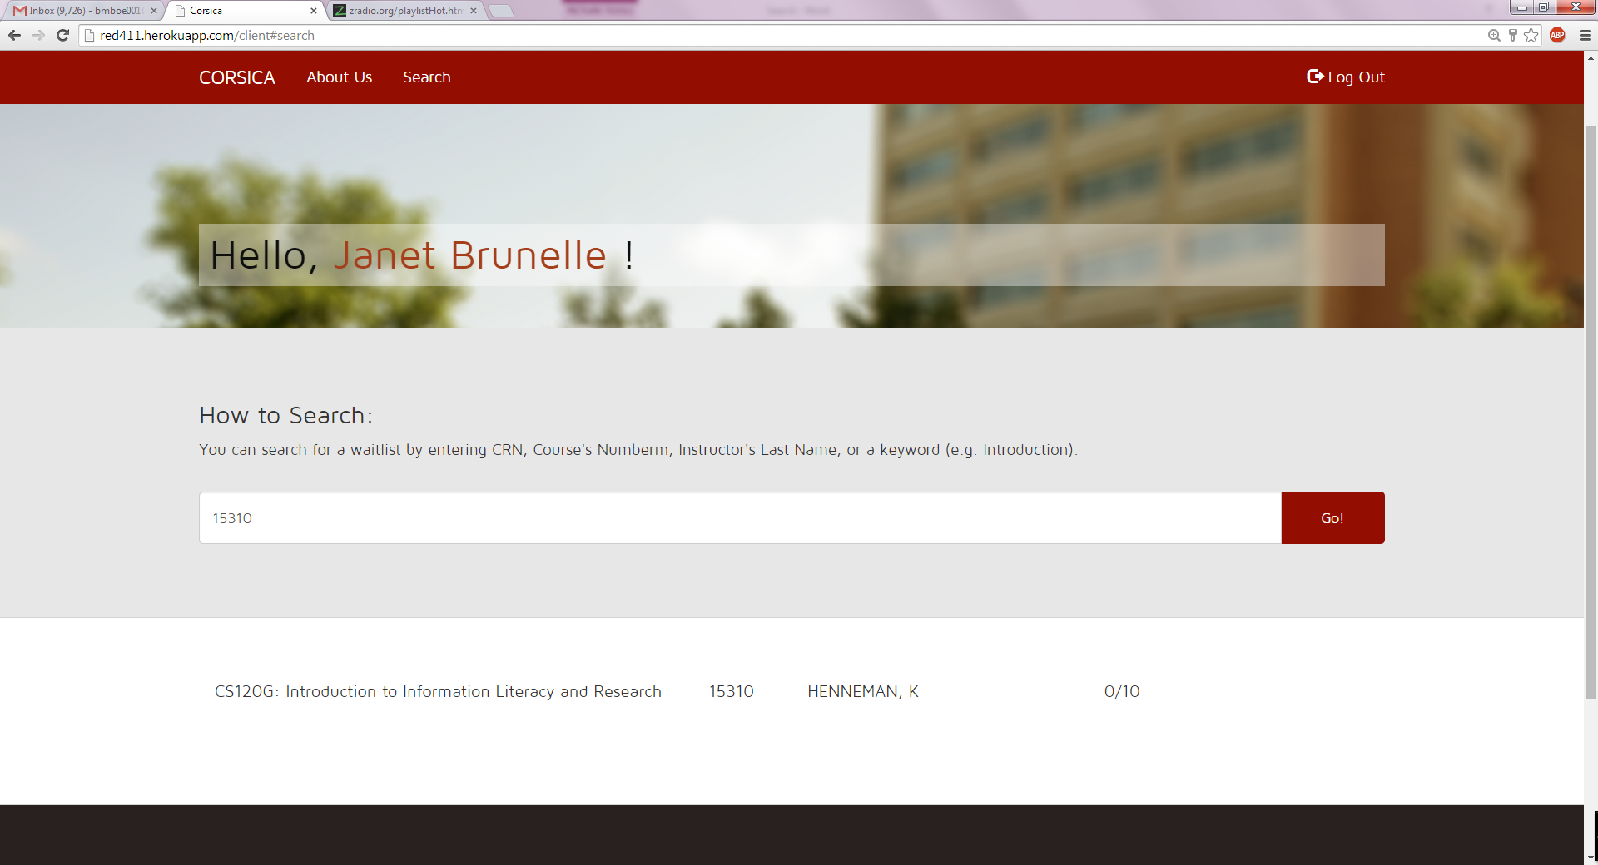

To use Search (Students):

1. Click on the word “Search” at the top of the page. You will then see the following screen:

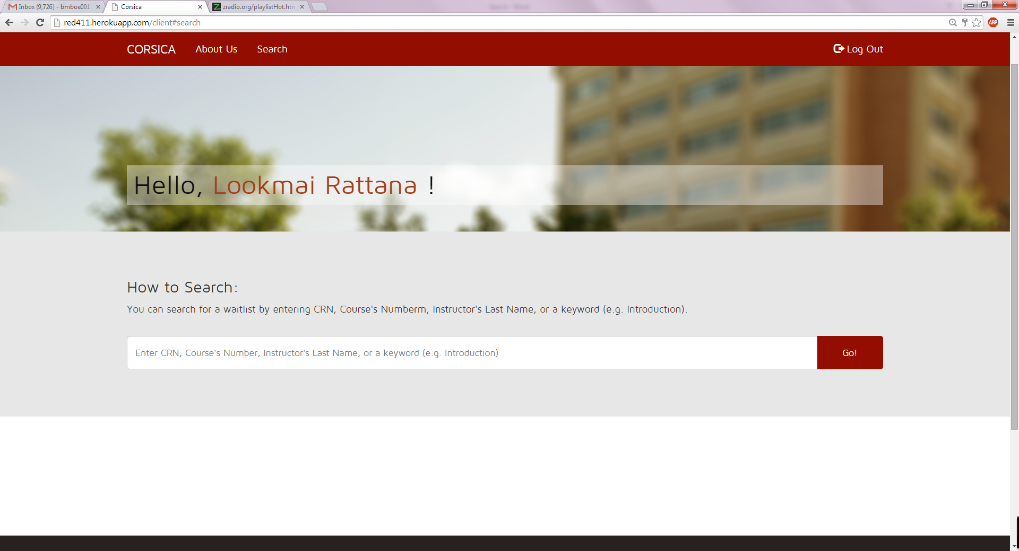

1. From here it’s pretty easy. Just type in the CRN, course number, Instructor’s Last Name, or keyword.

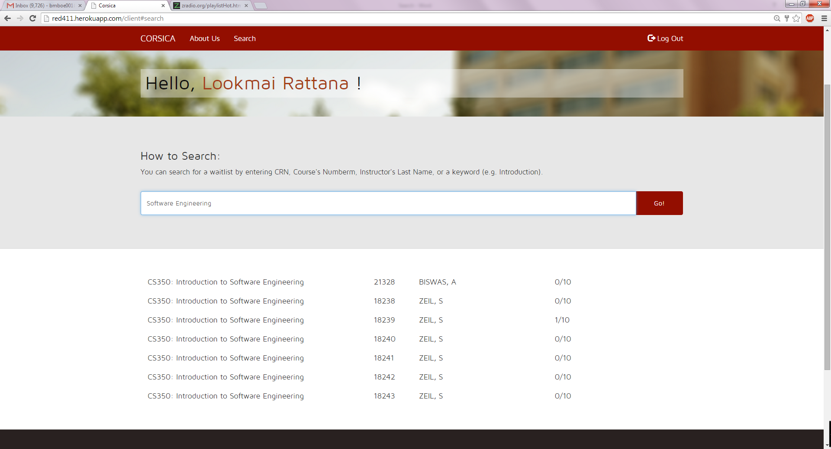

(This space intentionally left blank)

1. **Wait-lists (Nicholas)**

There will be different types of users using wait-lists. Administrators can remove or maneuver students on a wait-list. They can also add or remove wait-lists.

Advisors will have the same capabilities as Administrators, except they cannot add or remove wait-lists. Schedulers can add or remove a wait-list. Students can add or remove themselves from a wait-list.

1. Administrators

Step 1: Navigator to CORSICA using the URL provided and enter a valid email and password. (Figure 1)

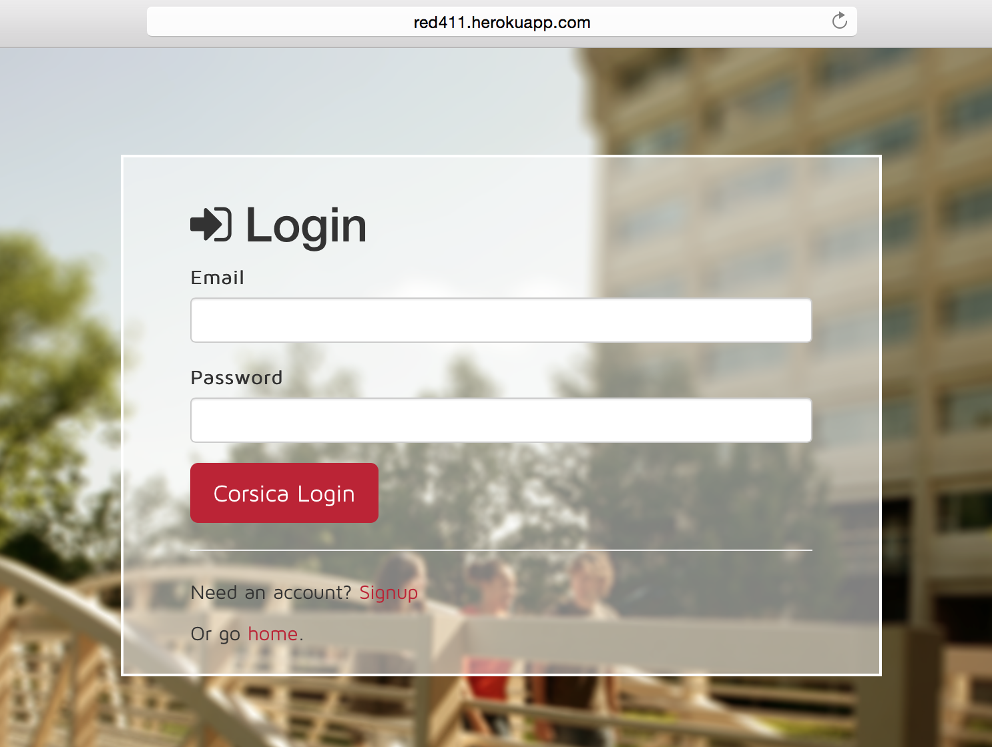

*Figure 1: Login Page*

Step 2: Click on a course to view the wait-list (Figure 2)

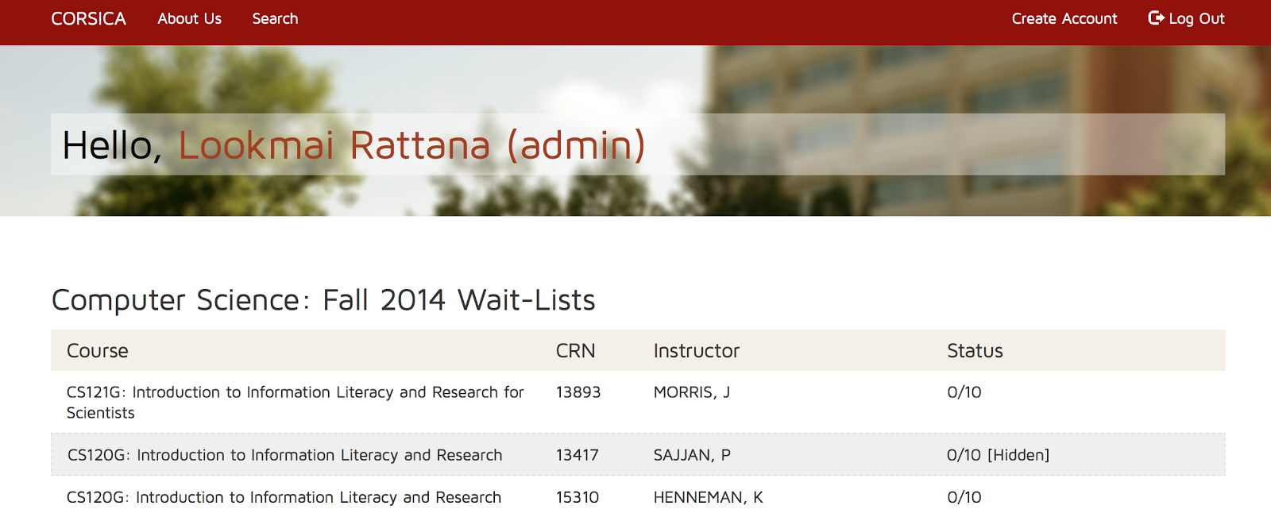

*Figure 2: Select Course*

Step 3: To maneuver a student on a wait-list click the up or down arrow next to a student’s name. (Figure 3)

Step 4: To remove a student from a wait-list, click the ‘x’ button next to a student’s name. (Figure 3)

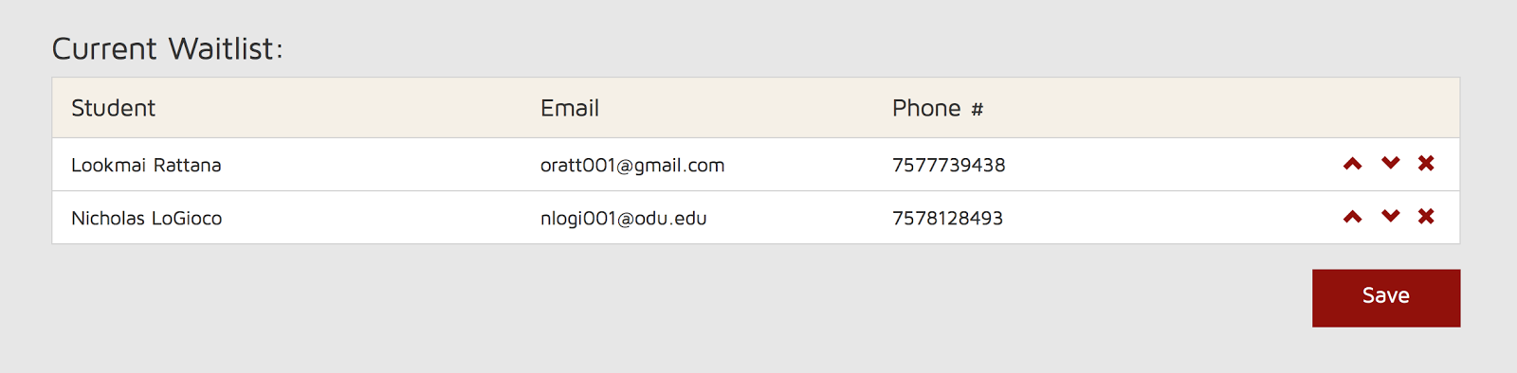

*Figure 3: Maneuver Students*

Step 5: To remove a wait-list from a course, click the ‘x’ button next to the course. (Figure 4)

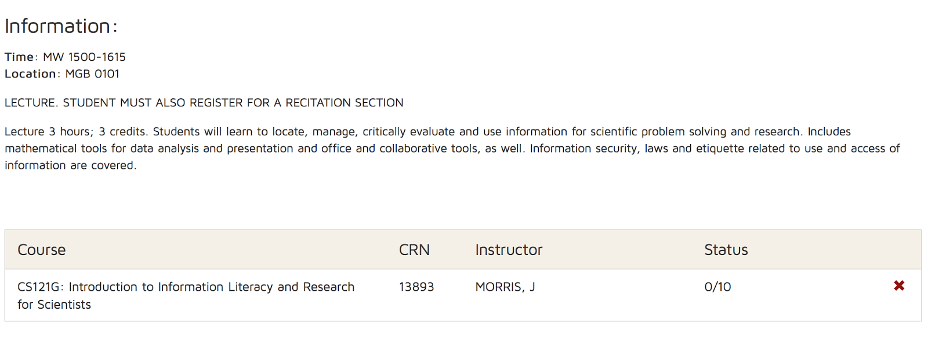

*Figure 4: Remove Wait-list from Course*

Step 6: To add a wait-list to a course, click the ‘+’ button next to the course. (Figure 5)

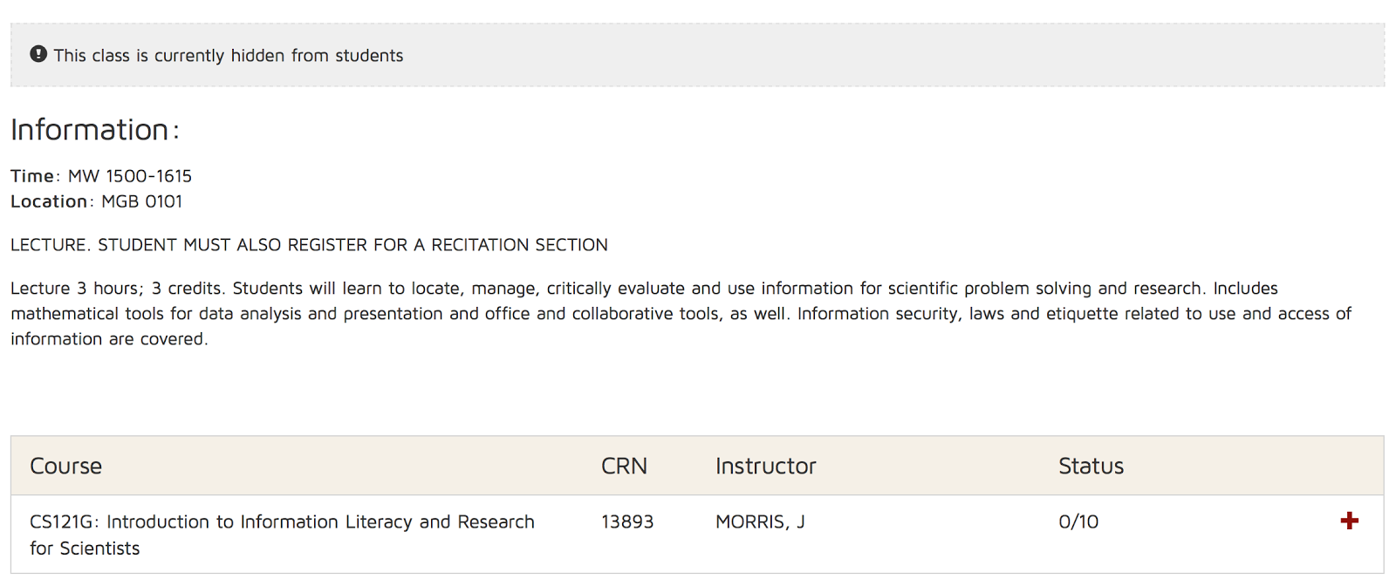

*Figure 5: Add Wait-list to Course*

1. Advisors

Step 1: Same as Administrators

Step 2: Same as Administrators

Step 3: Same as Administrators

Step 4: Same as Administrators

1. Schedulers

Step 1: Same as Administrators

Step 2: Same as Administrators

Step 3: Refer to Administrators “Step 5”

Step 4: Refer to Administrators “Step 6”

1. Students

Step 1: Same as Administrators

Step 2: Click on the search bar. (Figure 2)

Step 3: Search using CRN, Course Number, Course Name, Professor’s Last Name, or a keyboard. (Figure 6)

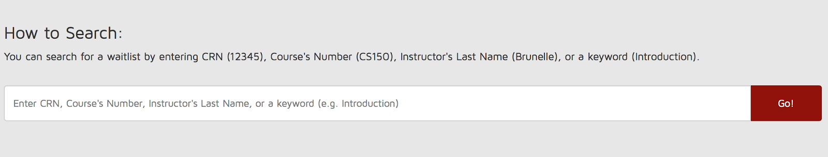

*Figure 6: Search Bar*

Step 4: Click on a course after searching. (Figure 7)

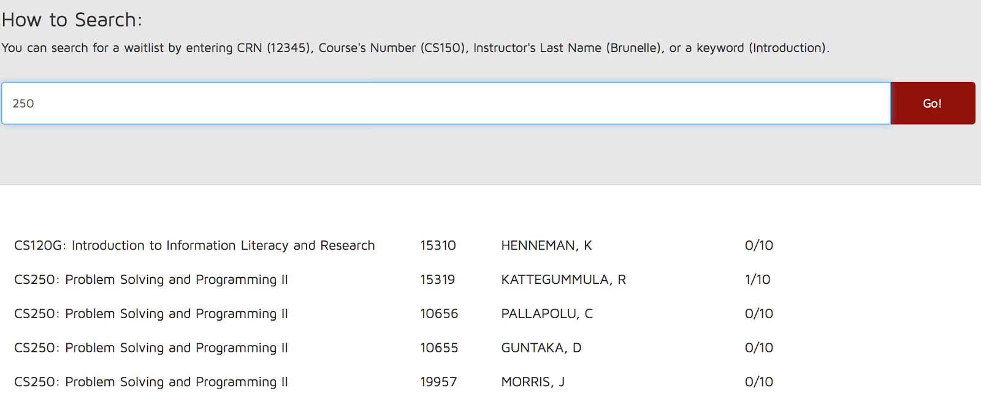

*Figure 7: Search Results*

Step 5: To add yourself to a wait-list, click the “queue” button. (Figure 8)

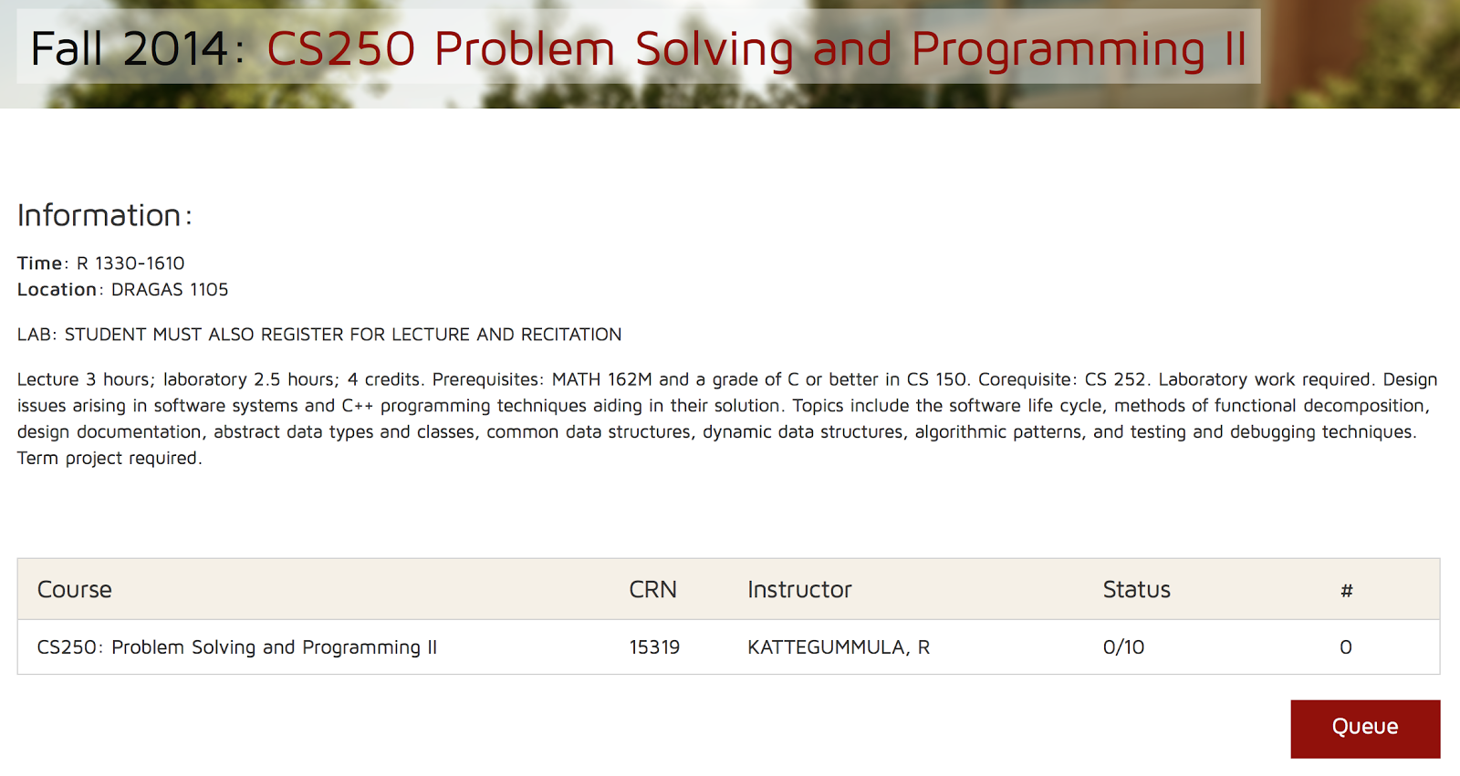

*Figure 8: Add Student to Wait-list*

Step 6: To remove yourself from a wait-list, click the “Unsubscribe” button. (Figure 9)

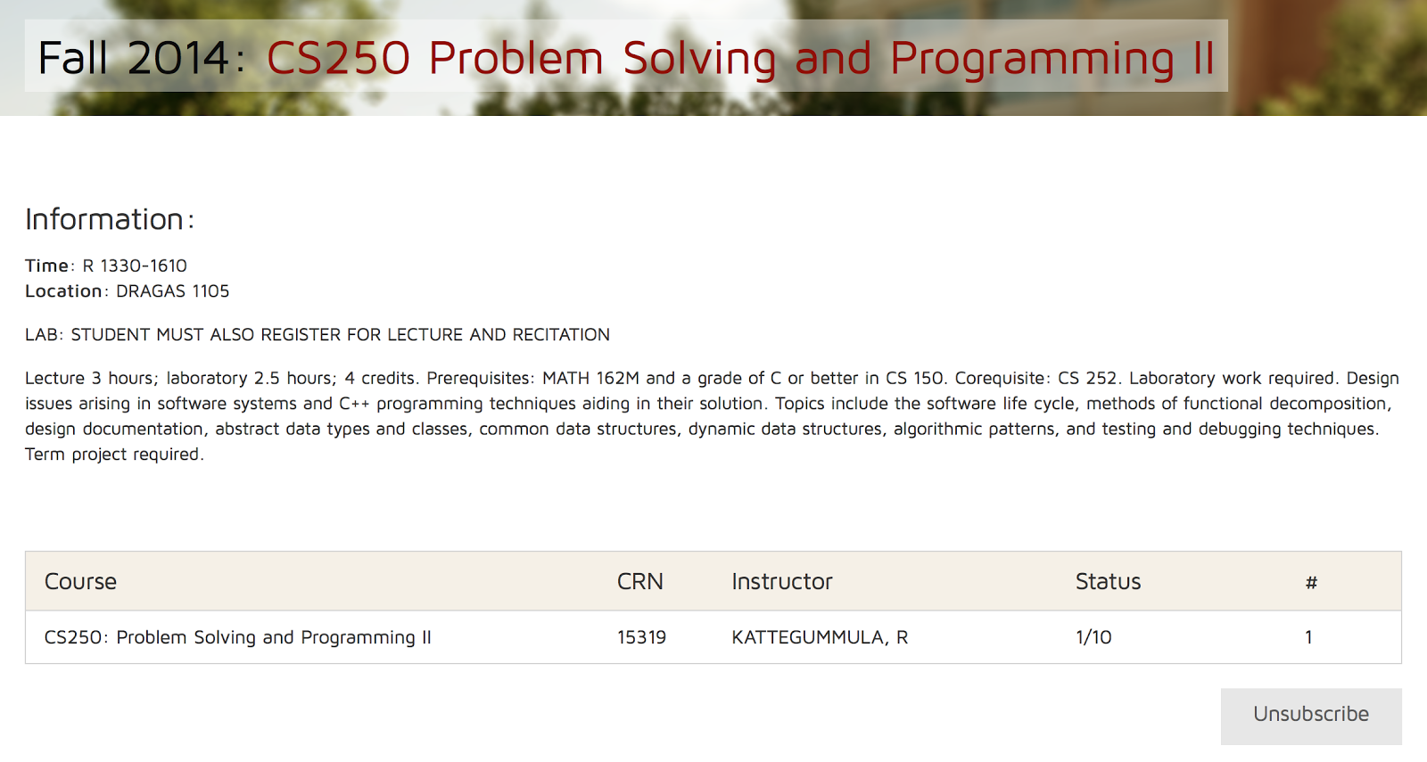

*Figure 9: Remove Student from Wait-list*

(This space is intentionally left blank.)

# **User Accounts (Anthony)**

In this section we will explore what CORSICA users may do. The user types include: Administrator, Advisor, Scheduler, Student, and Guest. This manual will first examine the Administrator user. Upon the initial log on, the Admin is directed to their version of the CORSICA dashboard as shown in Figure 1.

## **5.1 Administrator User**

The Administrator User has the most abilities out of all the user types. They are able to do everything the Advisor and Scheduler users can do. In addition to these abilities, they are able to add and remove all user types from CORSICA.

(This space intentionally left blank)

### **Administrator Dashboard**

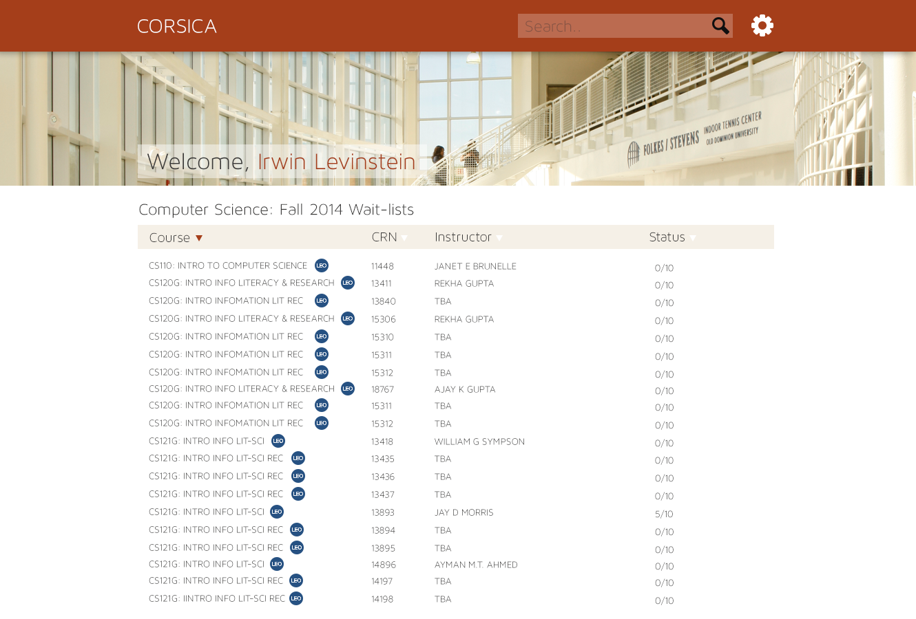

Figure 1- Administrator Dashboard

From the dashboard, the Admin will see a list of currently active wait-lists that display: course name, course CRN, the instructor, and the amount of students signed up on the wait-list. The admin may add a course to the currently active wait-lists by doing the following:

Step 1: Scroll to the bottom of their dashboard.  
 Step 2: Click the “Add Course” button that is shown in Figure 2.  
 Step 3: Fill out the requested information.

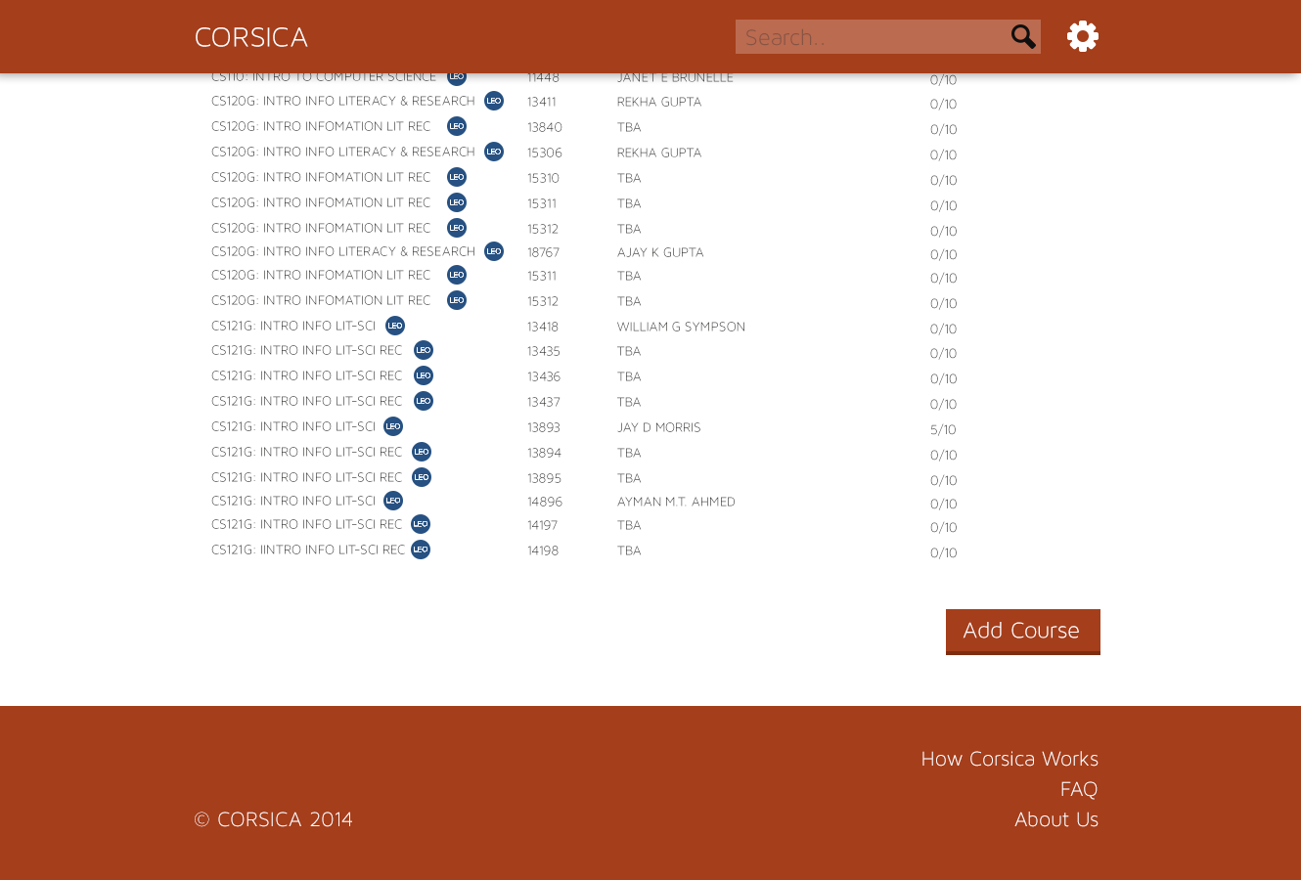

Figure 2- Admin Add Course

### **Administrator Search**

An admin user may search for a particular student by typing the name of the student in the search bar that is found in the top right corner of their dashboard.

### 

Figure 3- Search Bar

After the student search is performed the Admin may view any wait-lists the searched student is enrolled in. In the Figure 4 example, Latimer Gerle was searched and the wait-lists she is enrolled in are displayed.

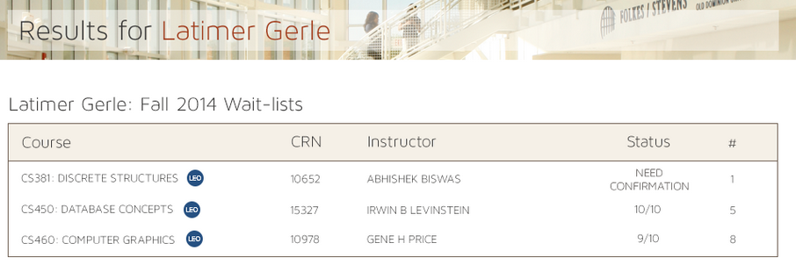

Figure 4- Search Result

* + - 1. **Administrator Wait-list detail**

An admin user may display the details about a course wait-list. The user will see the students that are enrolled in the wait-list. Students may be moved or deleted by the admin on this screen. In the Figure 5 example, CS 250 was searched.

(This space intentionally left blank)

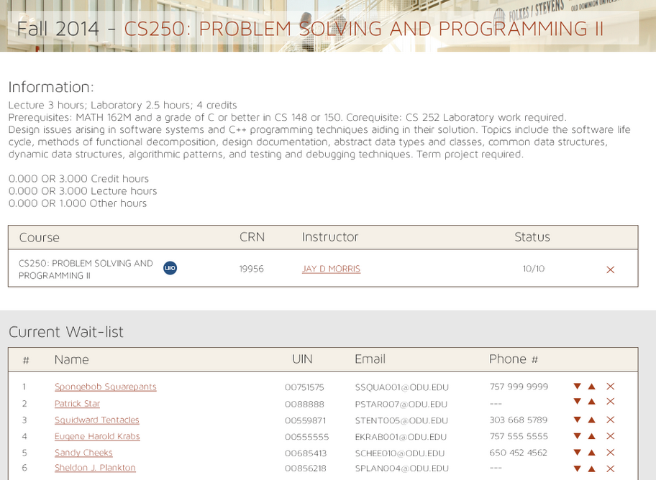

Figure 5- Course Search

## **5.2 Advisor User**

The Advisor User is responsible for leading students on the correct path throughout their academic career. They will have the ability to move students on the wait-list in a special case incident where a student needs one last course to graduate when compared to a freshman. They will also be able to delete students off of the wait-list.

### **Advisor Dashboard**

Same as Administrator User

### **Advisor Search**

Same as Administrator User

### **Advisor Student Detail**

Same as Administrator User

### **Advisor Wait-list Detail**

Same as Administrator User

## **5.3 Scheduler User**

The Scheduler User is in charge of setting up what courses are eligible to have wait-lists. They are able to add wait-lists and remove them.

### **Scheduler Dashboard**

Same as Administrator User

### **Scheduler Search**

Same as Administrator User

### **Scheduler Wait-list Detail**

Same as Administrator User

## **5.4 Student User**

The Student User will make up the majority of CORSICA’s user base. The student will be able to:

* Create account
* Search for a course
* Search for a keyword
* Search for a CRN
* Search for instructor
* Add to queue
* Remove from queue
* Can’t add yourself to queue because queue is filled
* Notification via email
* Notification via email and text

### **Student Dashboard**

Once a student user has logged into CORSICA, their dashboard will display all current wait-lists that student is enrolled in. Figure 6 shows a student who has logged in and is enrolled in three wait-lists.

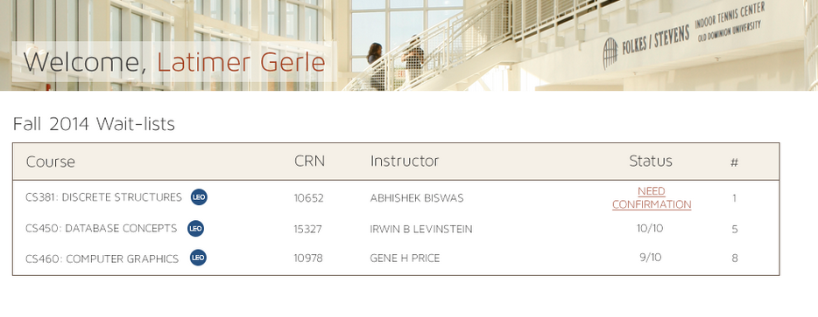

Figure 6- Student Dashboard

### **Student Search**

A student user may search for a particular professor by typing their last name into the search bar at the top right of their dashboard. Figure 7 shows an example of a student searching for Professor Brunelle. The course wait-lists that have the searched professor as the instructor are displayed.

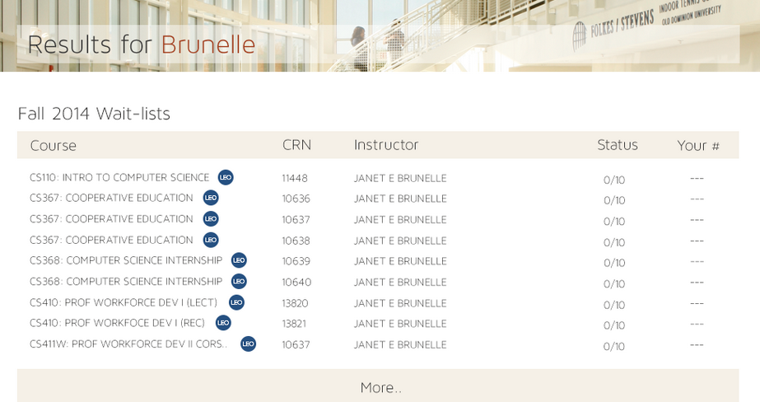

Figure 7- Student Search

### **Student Wait-list Sign Up**

In order for a student to queue for a course wait-list they must:

Step 1: Log into CORSICA

Step 2: Search for the course wait-list they wish to enroll in.

Step 3: If there is space available, they must click the “Queue” button as shown in Figure 8.

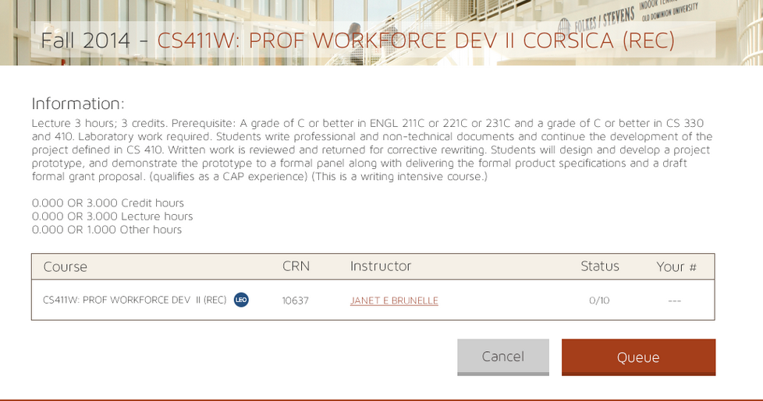

Figure 8- Student Wait-list sign up

Step 4: After pressing the queue button, the student will receive a confirmation pop up detailing their successful action and their position on the course wait-list as shown in Figure 9.

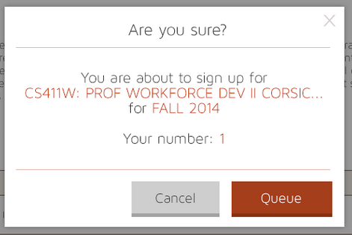

Figure 9- Student Confirmation

## **5.5 Visitor User**

The Visitor User will have the least amount of abilities. They will only be able to view the FAQs page and the About Us page in CORSICA.

(This space intentionally left blank)

1. **Troubleshooting (Lookmai)**